Project Synopsis

Title: Enable MFA for IAM User and Federated User Using Authenticator App

Project Domain : Cloud Computing / Amazon Web Services (AWS)
Project Type : Academic Project

Sr.no. | TEAM MEMBER | ROLL NUMBER
1. | OJAS SARASWAT | 2415001068
2. | PALAK BINDAL | 2415001078
3. | SHIVAM BRITHARIYA | 2415001495
4. | SAFAL PANDEY | 2415001356

- Step 1: The dashboard shows Recently visited services like IAM, S3, EC2, CloudFront, Billing, VPC, DynamoDB, CloudWatch, and Lambda for quick access.
- Step 2: The Welcome to AWS section provides links for getting started, training & certification, and AWS Builder Center.
- Step 3: The AWS Health widget displays system health details — open issues (0), scheduled changes (1), and notifications (0).
- Step 4: The Cost and usage section shows billing and usage information for the current month.

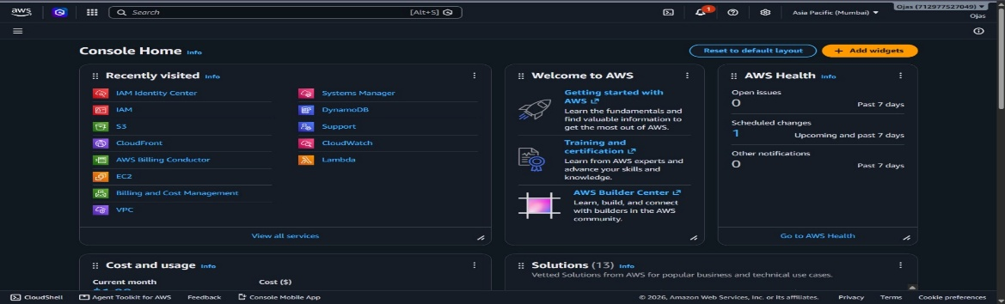

Step 1: The search bar at the top is used with the keyword “iam” to quickly find related AWS services.
Step 2: Under Services, results show IAM (manages access), IAM Identity Center (workforce access), and Resource Access Manager (share resources).
Step 3: Under Features, options like IAM Access Analyzer for S3, Groups, and Projects are displayed to manage permissions and organize users.
Step 4: On the right side, the AWS Health widget shows system health details — open issues (0), scheduled changes (1), and notifications (0).
Step 5: The console is set to the Asia Pacific (Mumbai) region, with the account name visible, showing where resources are managed.

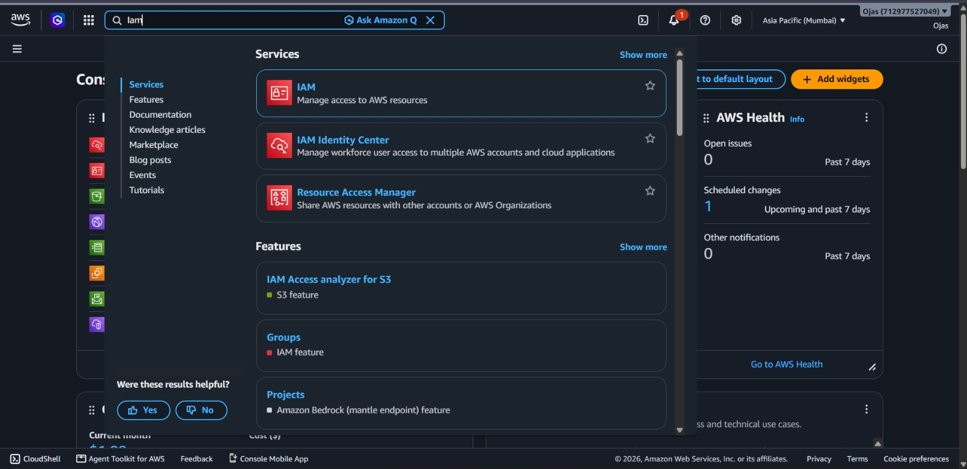

Step 1: The Security recommendations section advises enabling MFA for the root user and deactivating/deleting root access keys to improve account security.
Step 2: The IAM resources section shows counts of groups (2), users (3), roles (9), policies (0), and identity providers (0).
Step 3: The AWS Account section displays the account ID, option to create an alias, and the IAM sign-in URL for users.
Step 4: The Quick Links section provides shortcuts to manage security credentials and MFA settings.
Step 5: The Tools section highlights the Policy Simulator for testing and evaluating IAM policies.
Step 6: The What’s new section lists updates such as higher quotas for roles, trust policies, and identity providers.

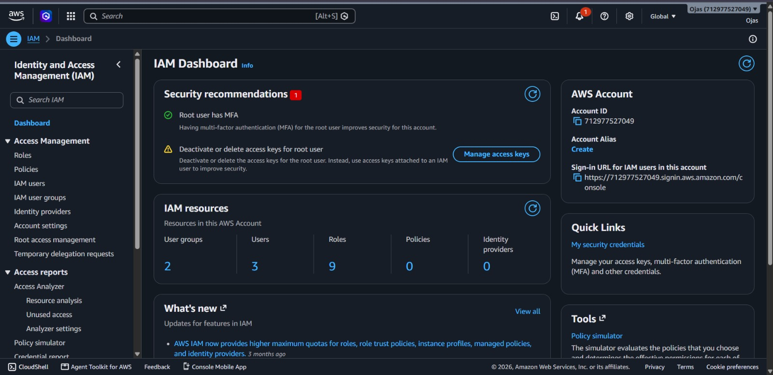

Step 1: The IAM users section lists three users — AdminUser, DeveloperUser, and MFATestUser.
Step 2: Each user entry shows details like path, group, last activity, MFA status, password age, and console sign-in.
Step 3: The AdminUser and DeveloperUser accounts have a password age of 31 days, while MFATestUser has a password age of 5 days and last activity 5 days ago.
Step 4: The MFA column shows “Virtual” for MFATestUser, meaning multi-factor authentication is enabled for that account.
Step 5: The left sidebar provides navigation options such as Dashboard, Roles, Policies, IAM users, IAM groups, Identity providers, Account settings, Root access, and Temporary delegation requests.
Step 6: The top banner highlights AWS Identity Center, suggesting streamlined human access to AWS and cloud apps.
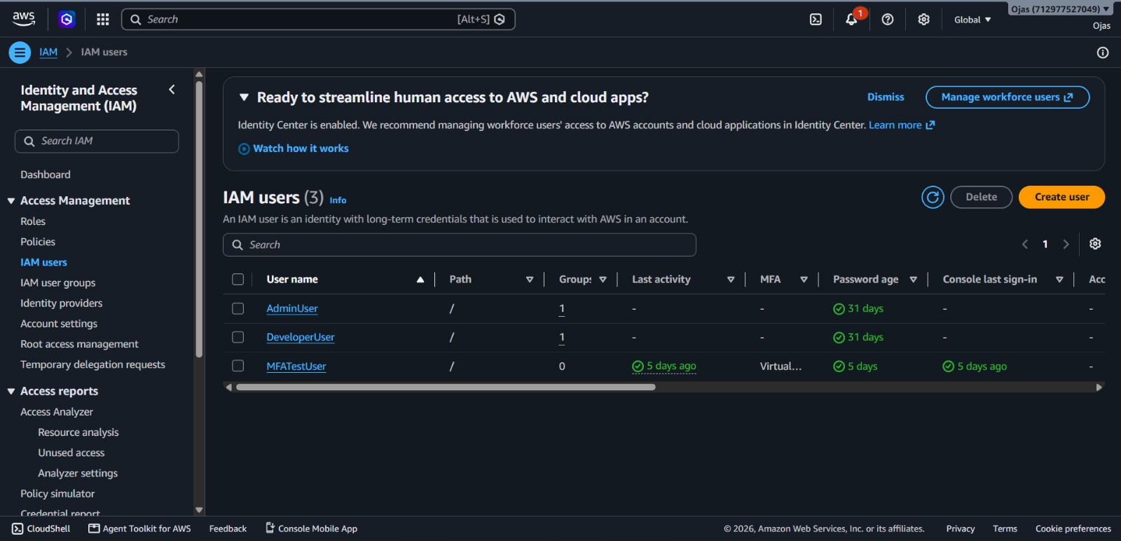

Step 1: The User Summary shows ARN, creation date, console access (enabled with MFA), and last sign-in details.
Step 2: It indicates the user has one access key, with an option to create a new one.
Step 3: The Permissions tab lists two attached policies — AmazonEC2FullAccess and AmazonS3ReadOnlyAccess.
Step 4: Options are available to simulate, remove, or add permissions for this user.
Step 5: The left sidebar provides navigation for roles, policies, user groups, account settings, and reports.

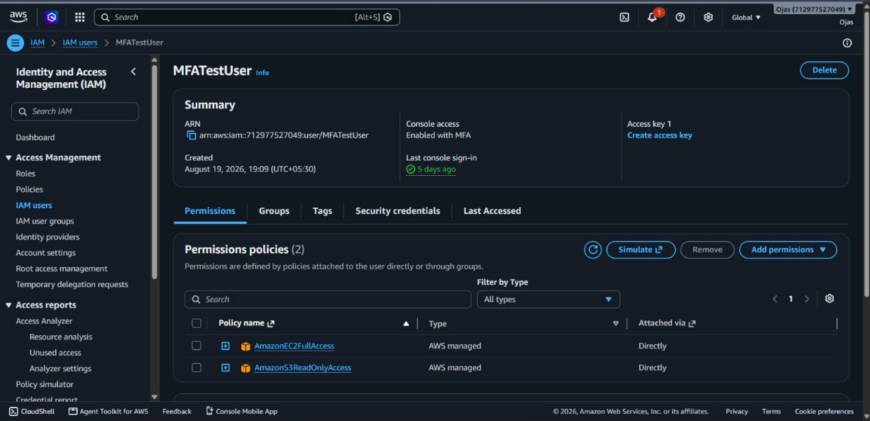
Step 1: The Console sign-in section shows the sign-in URL, password update date (5 days ago), and last console sign-in (5 days ago).
Step 2: The Multi-factor authentication (MFA) section indicates a virtual MFA device is assigned, with options to remove, resync, or assign a new device.
Step 3: The Access keys section explains programmatic access to AWS services, showing no active keys but an option to create one.

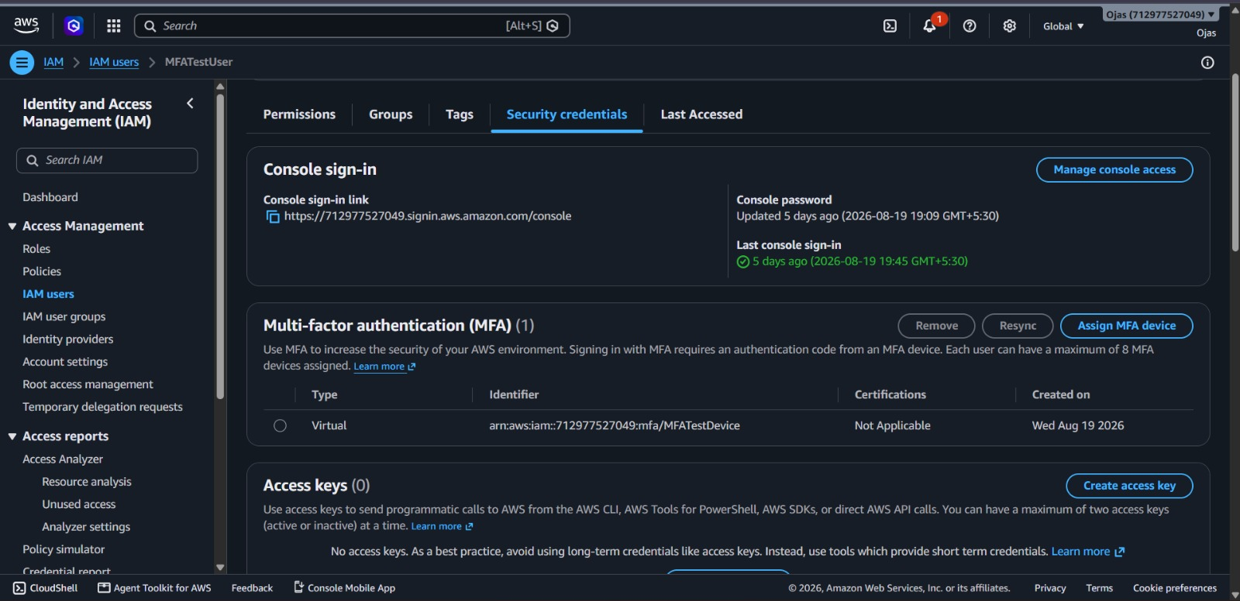

Step 1: The page shows the IAM user sign-in form with fields for Account ID/Alias, IAM username, and Password.
Step 2: Options like “Remember this account,” “Show Password,” and links for “Having trouble?” or “Sign in using root user email” are provided.
Step 3: A yellow Sign in button is displayed to access the AWS console.
Step 4: A notice at the top mentions upcoming updates to the AWS sign-in experience starting mid-2026.
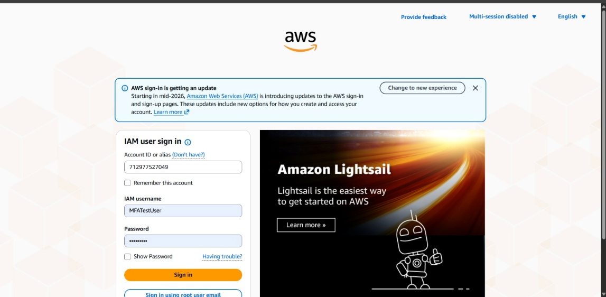

Step 1: The Recently visited section shows no services yet, but suggests commonly used ones like EC2, S3, CloudWatch, and IAM.
Step 2: The Welcome to AWS section provides links for getting started, training & certification, and AWS Builder Center.
Step 3: The AWS Health section states “No health data” and indicates the user does not have permission to access AWS Health.
Step 4: The Cost and usage section includes placeholders for current month and cost breakdown, though no data is shown.
Step 5: The Solutions section highlights 13 vetted AWS solutions for business and technical use cases.
Step 6: The top navigation bar shows options for search, notifications, settings, region selection (Europe – Stockholm), and account details (MFA test user).
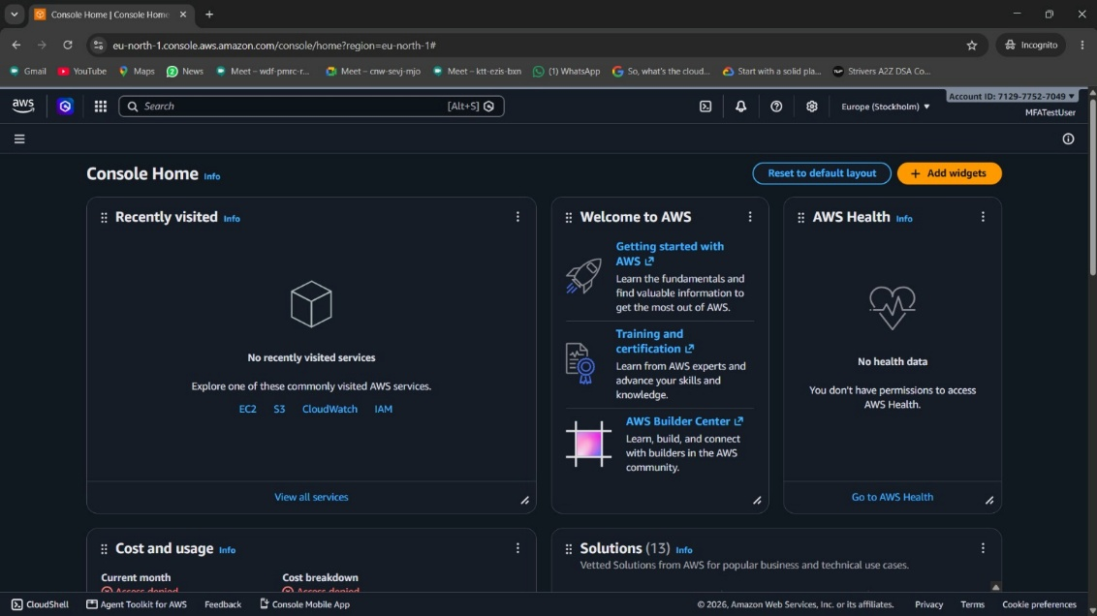
Step 1: The search shows IAM Identity Center, which manages workforce access to multiple AWS accounts and cloud applications.
Step 2: It also lists IAM, used to manage access to AWS resources securely.
Step 3: Another service shown is AWS Entity Resolution, which uses machine learning for entity resolution tasks.
Step 4: Under Features, options include Identity providers, IAM Access Analyzer for S3, and Groups.
Step 5: On the right side, there are quick actions like managing console access, assigning MFA devices, and creating access keys.
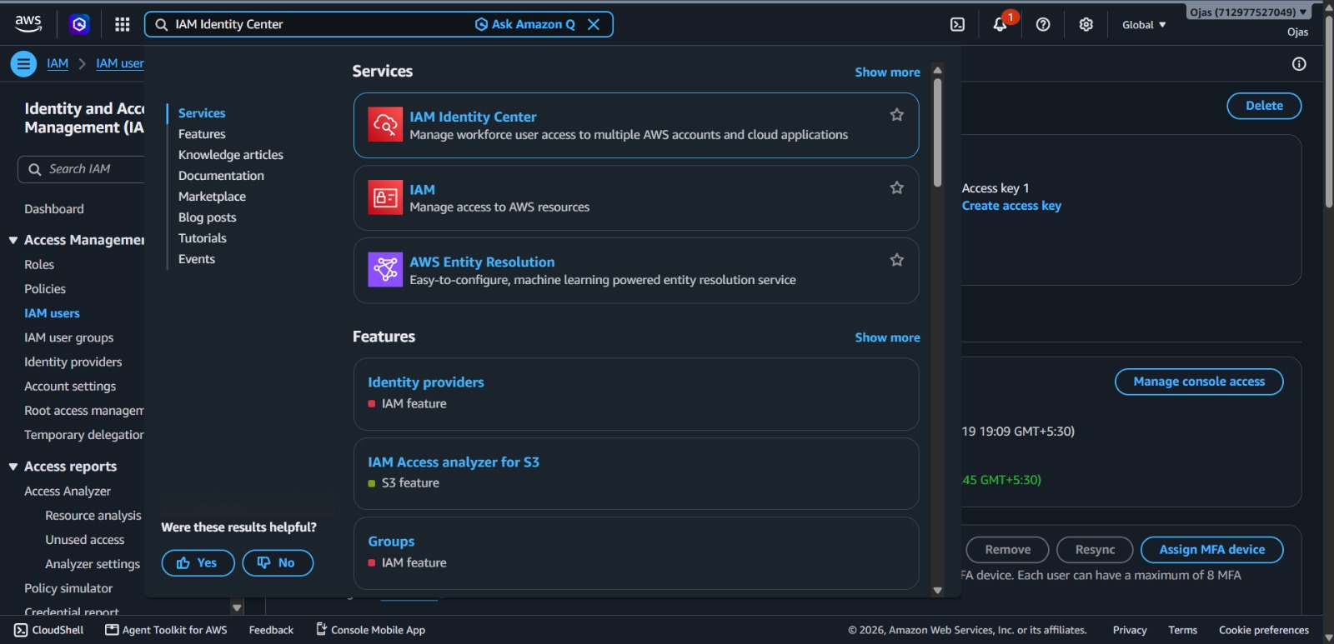

Step 1: Dashboard shows IAM Identity Center for managing user access and permissions.
Step 2: Sidebar includes Users, Groups, Settings, Multi-account permissions, and Application assignments.
Step 3: Central management explains SCPs and monitoring member accounts.
Step 4: Warning box notes member accounts can enable apps independently.
Step 5: Settings summary shows instance name, identity source, region, org ID, and issuer URL
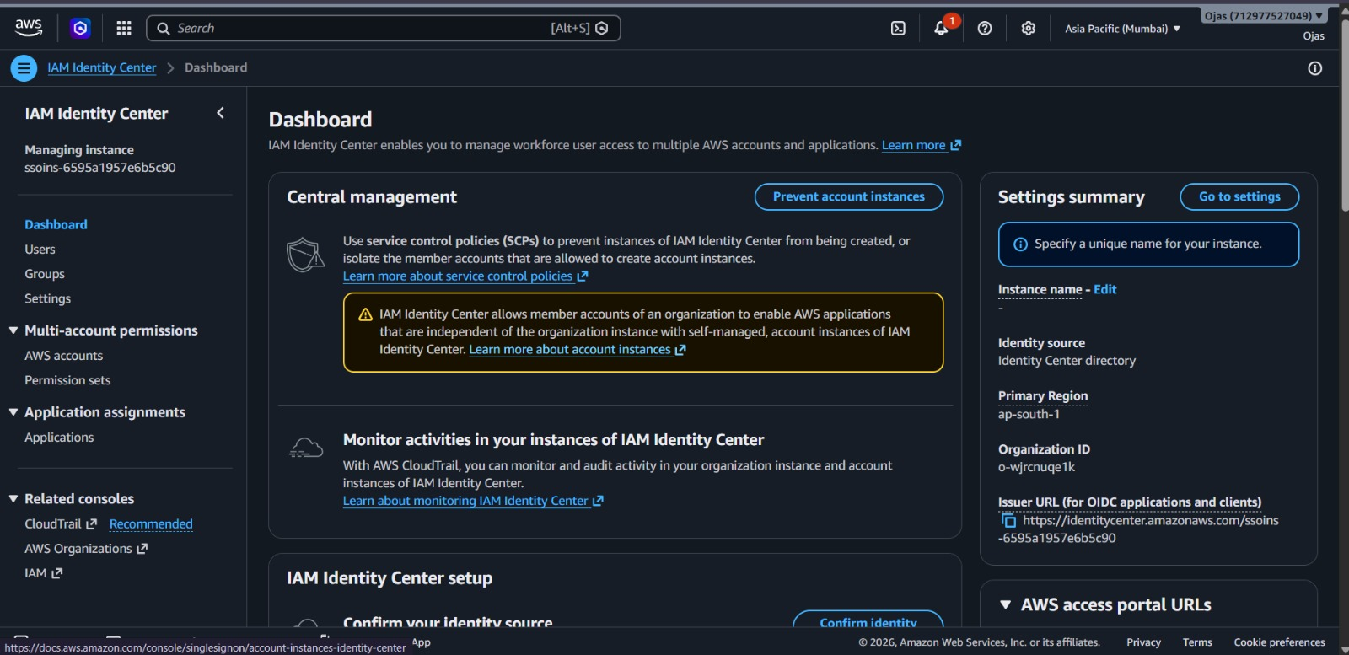

Step 1: The Users list shows one user named FederatedUser with display name Ojas Saraswat.
Step 2: The user status is Enabled (green check mark).
Step 3: The account has one MFA device attached for security.
Step 4: The user was created manually.
Step 5: Sidebar includes options like Dashboard, Users, Groups, Settings, Multi-account permissions, and Application assignments.
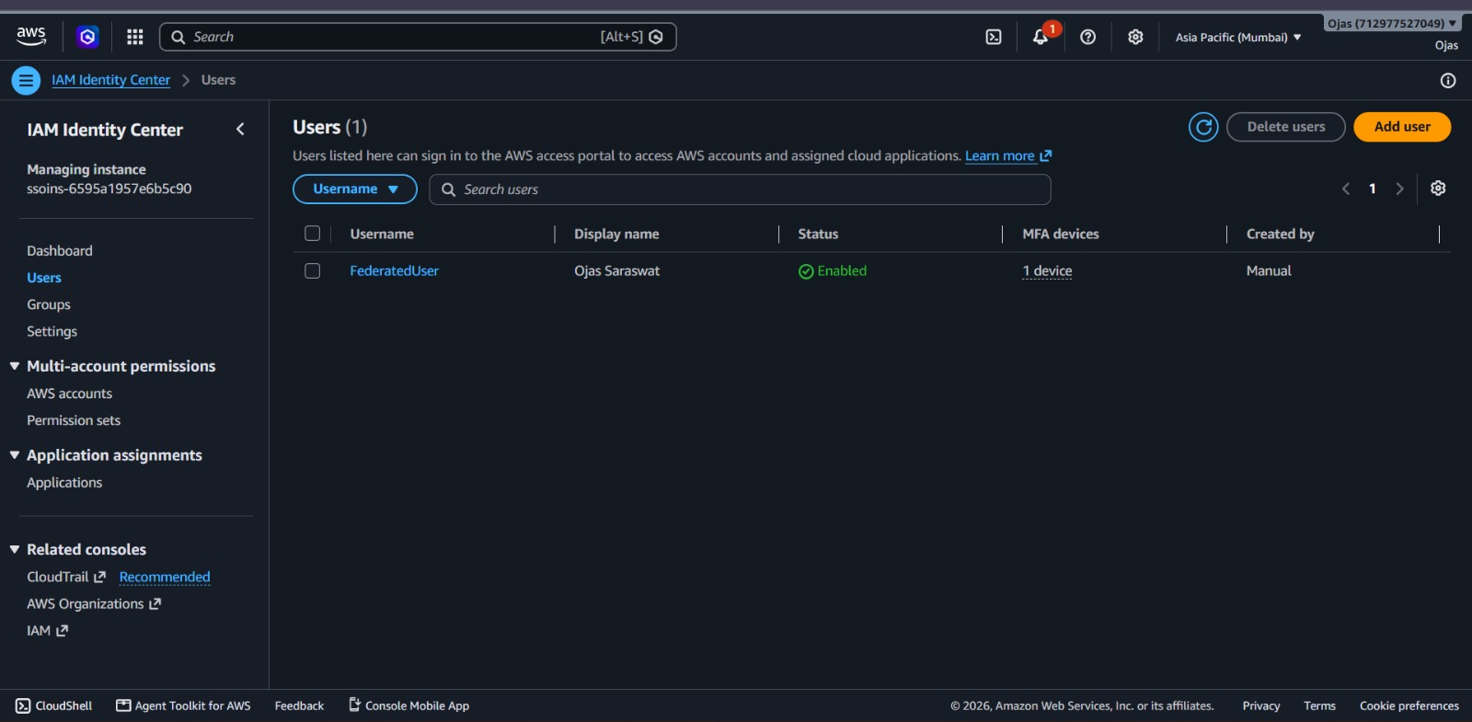

Step 1: A yellow banner shows the email is not verified, reminding that verification is needed for features like email-based two-step sign-in.
Step 2: Buttons allow actions such as reset password, delete user, or send verification link.
Step 3: General information shows User ID, status (Enabled), created time, and last updated details.
Step 4: Tabs include Profile, Groups, AWS accounts, Applications, MFA devices, and Active sessions.
Step 5: Sidebar navigation offers Dashboard, Users, Groups, Settings, Multi-account permissions, and Application assignments.
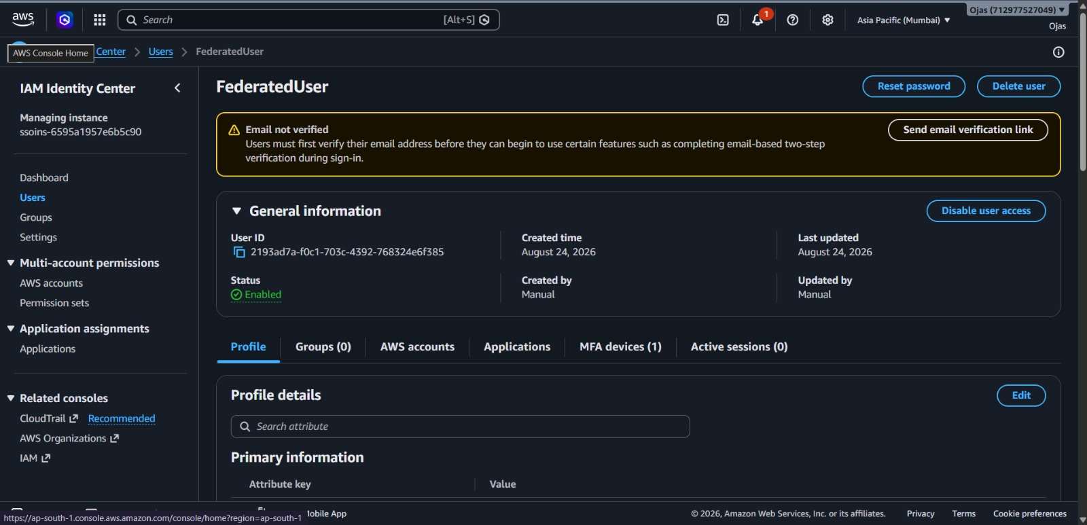

Step 1: A yellow warning shows email not verified, required for features like two-step sign-in.
Step 2: Action buttons include reset password, delete user, send verification link, and disable user access.
Step 3: General info shows User ID, status (Enabled), created/updated date, and manual creation.
Step 4: Tabs include Profile, Groups, AWS accounts, Applications, MFA devices, and Active sessions.
Step 5: The MFA devices tab shows one registered authenticator app created on August 24, 2026.
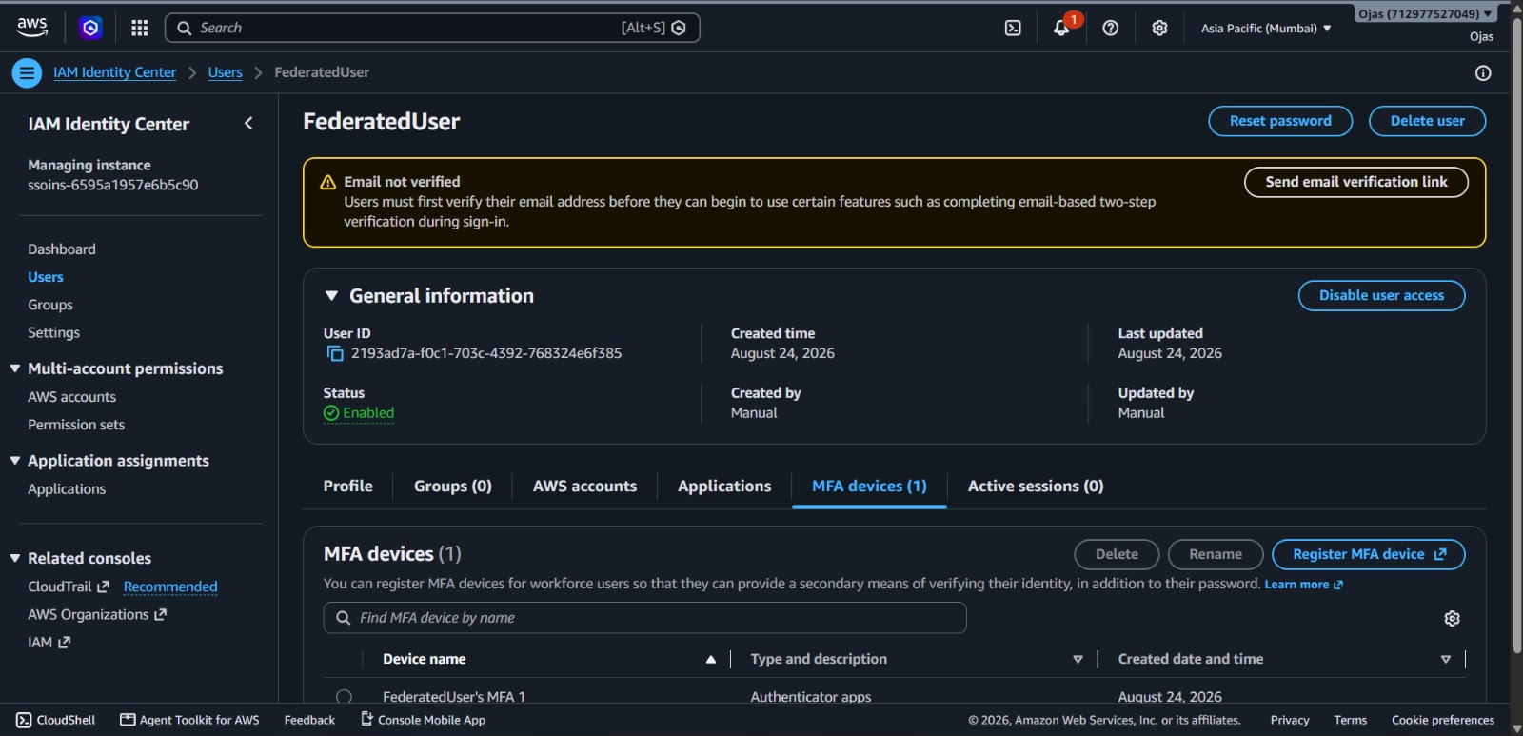

Step 1: The login box shows the AWS logo and a field with username “FederatedUser.”
Step 2: A Next button is provided to continue sign-in.
Step 3: A note below mentions agreement to AWS terms, privacy notice, and cookie usage.
Step 4: Background design features geometric cube patterns in blue and purple tones.
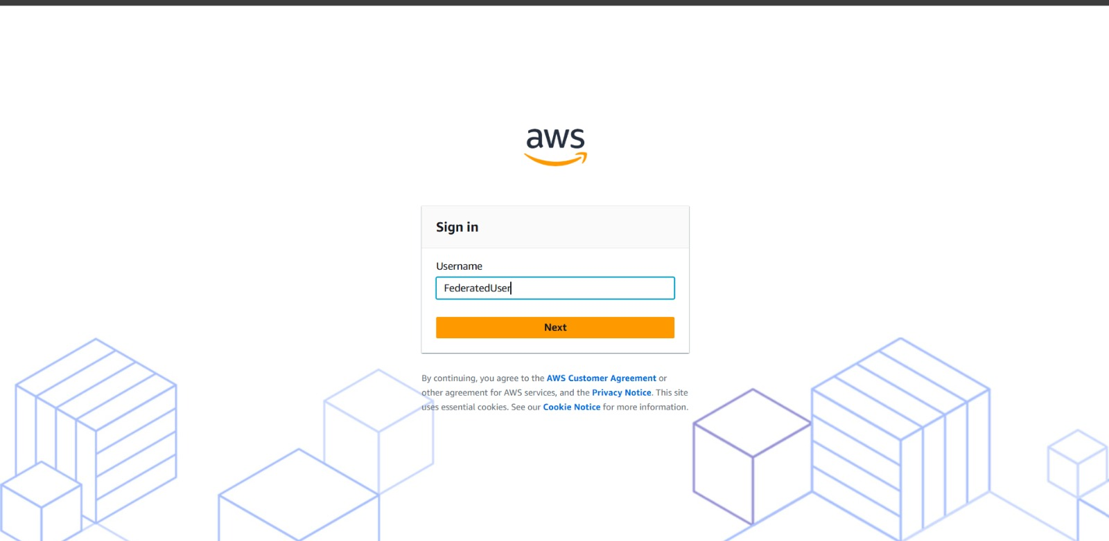
Step 1: The login box shows username “FederatedUser (not you?)” with a password field.
Step 2: Options include “Show password” and “Forgot password?”.
Step 3: A yellow Sign in button is displayed.
Step 4: Checkbox option “This is a trusted device” with a learn more link.
Step 5: Background has cube-style graphics representing cloud infrastructure.
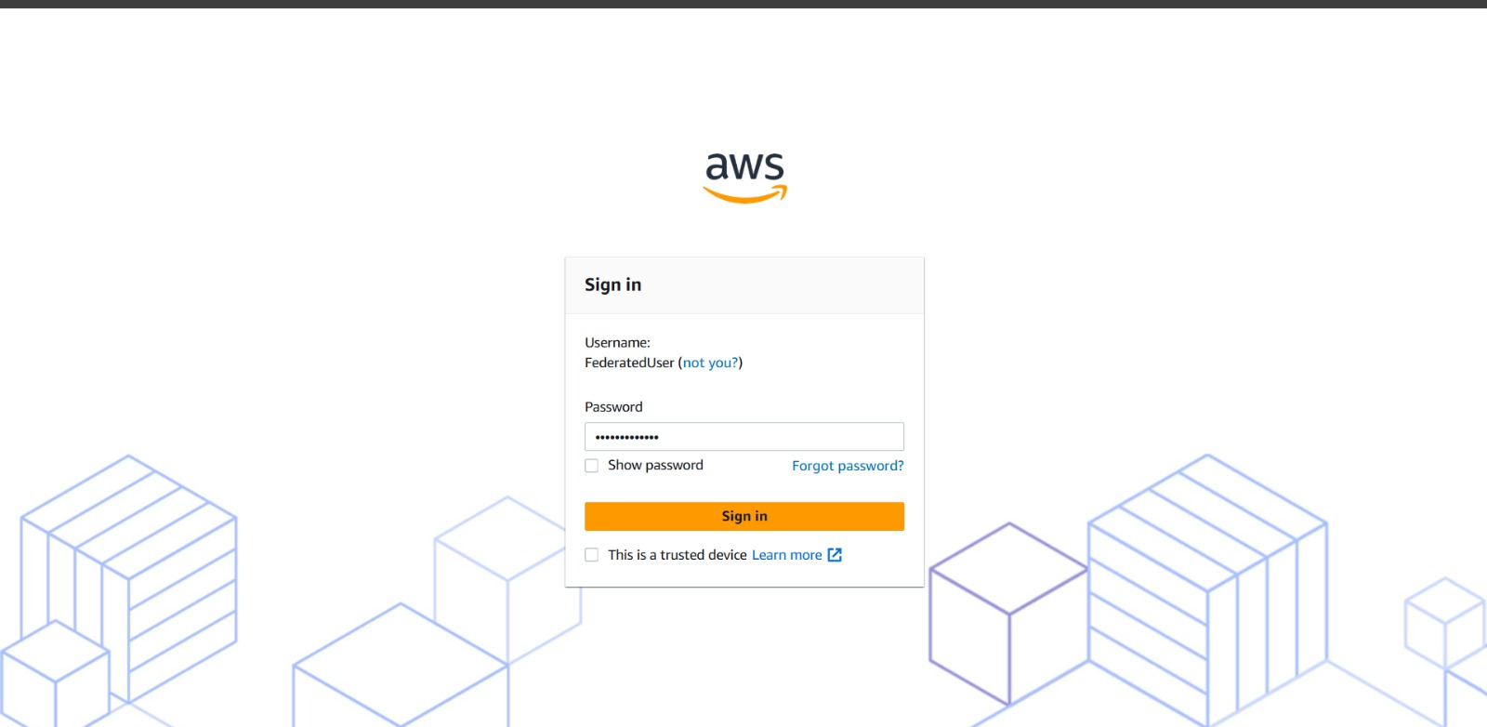
Step 1: The Accounts tab is selected, showing “AWS accounts (0)” with no linked accounts.
Step 2: A search bar allows filtering by name, ID, or email.
Step 3: Columns for Account Name, Account ID, and Email are displayed but empty.
Step 4: A Create shortcut button is available on the right.
